Exercises

1:Which of the following are valid variable names?
XxXxXx valid

_ valid

12345 invalid

HOMEDIR valid

file.name valid

_date valid

file_name valid

x0-9 valid

file1 valid

Slimit valid

2:Suppose that your HOME directory is /users/steve and that you have subdirectories as shown in the following figure:
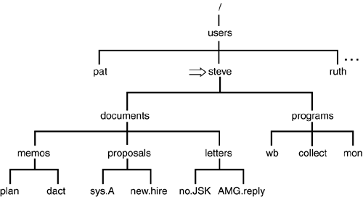

Assuming that you just logged in to the system and executed the following commands:

$ docs=/users/steve/documents
$ let=$docs/letters
$ prop=$docs/proposals$

write the commands in terms of these variables to
a.List the contents of the documents directory.

ls $docs

b.Copy all files from the letters directory to the proposals directory.

letFiles=$let/*
cp $letFiles $prop

c.Move all files whose names contain a capital letter from the letters directory to the current directory.

letCapFiles=$let/[A-Z]*
mv $letCapFiles $prop

d.Count the number of files in the memos directory.

What would be the effect of the following commands?
a.ls $let/..

a list of the documents

b.cat $prop/sys.A >> $let/no.JSK

appends the contents of sys.A to the end of no.Jsk file

c.echo $let/*

display all contents of the letters directory

d.cp $let/no.JSK $progs

copies no.JSK to the progs

e.cd $prop

changes the actual directory to the proposal directory

3:Write a program called nf to display the number of files in your current directory. Type in the program and test it out.

clas0115@localhost:~/Documents/Chapter2> ls > list
clas0115@localhost:~/Documents/Chapter2> wc -w list
15 list
clas0115@localhost:~/Documents/Chapter2>

4:Write a program called whos to display a sorted list of the logged-in users. Just display the usernames and no other information. Type in the program and test it out.

clas0115@localhost:~/Documents/Chapter2> echo "who | cut -c1-8" > whos
clas0115@localhost:~/Documents/Chapter2> chmod +x whos
clas0115@localhost:~/Documents/Chapter2> ./whos
clas0115
clas0115

